Message Reader Android Application

Abstract
The scope of the Message Reader Android Application is to make you listen to your messages whenever you feel like, while keeping your hands and eyes free for other things. It reads the text messages. Thus it might be user friendly and very much useful/helpful to the person using it.
In the present days it is becoming highly impossible to find any person without a mobile. So, the increases in demand for mobiles are high and people are expecting new technologies in mobiles. Android came up with a solution to meet the demand for latest technology of mobiles. Android was founded in Palo Alto, California, United States in October 2003 by Andy Rubin (co-founder of Danger). Android is a Linux-based operating system for mobile devices such as smartphones and tablet computers. It is developed by the open handset alliance, led by Google and other companies. Android has a large community of developers writing applications that extend the functionality of the devices. So it would be safe to say that nearly every mobile phone sold-out in the past decade has SMS capabilities. So, here we are to introduce you an all new messaging technology called ‘MESSAGE READER’ a quick and latest way of messaging.
‘MESSAGE READER’, the name itself suggests a new era to our regular chats via messaging. In our day to day lives we do a lot of messaging with our friends and people we know. By installing message reader application in our android we can make this process easier and quicker. This application is based on the change of format of received message. When a sender sends a message the receiver will receive a message in audio format. Thus a new version for our regular chat is here. The receiver can reply via text quickly. By introducing this application in an android market we can improve the quality of messaging.

Existing system with limitations:

The present messaging system includes the manual opening and going through the message received by the receiver whenever he/she receives a message. Because of this the receiver cannot be hands-free due to the received message. The receiver may not have the knowledge of the message received even without having glimpse at it.
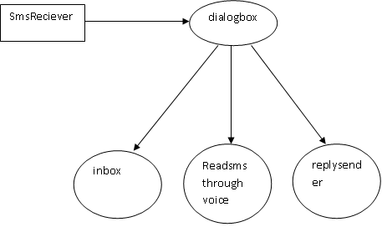
Data Flow diagram Context level
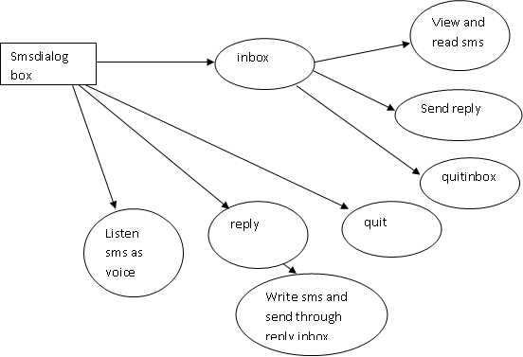
Data Flow diagram Top level

Proposed system with features:

The limitations of the regular sms system we already know that is the user should open the sms and he should read and there is no option called listening sms as voice so it is very difficult when the user is in some other busy work that is he may not be able to read sms when sms came. So we proposed one application that is whenever the sms came to mobile it will give some messaging box with someQUICK OPTIONS that is go to inbox, read sms and reply. So like in existing system the user need not to go through the more options for reading sms. He simply do any operation on sms box quickly.
The text message will be handled within Message Reader will only intercept the new message in order to be able to speak it to you, but your proper installed application. If you have Message Reader activated, and one message arrives to your phone, the process will be the following one:
- Message Reader detects the new message using a broadcast receiver (until this moment the app has not been wasting battery)
- Starts a background service with the TTS system, when all the work is done, Message Reader will start to speak the message.
While the Message Reader is active, your phone OS (Android) saves your new messages and usually generates a new notification and your Message Reader app will alert you. For example, I have a SMS ‘X’ and after Message Reader reads the message, I can also manually read the SMS in SMS ‘X’.
The main characteristics are:
- The application reads all SMS text messages by voice, the moment you get them.
- It reads the contact name from your address phone book instead of the phone number.
- Abbreviations management (add / edit / delete your own abbreviations).
- Message Reader will not waste phone battery. Message Reader will be active only when the SMS arrives.
- Language settings are automatically detected from phone location and language configuration.

HARDWARE REQUIREMENT
CPU type : Intel Pentium 4
Clock speed : 3.0 GHz
Ram size : 512 MB
Hard disk capacity : 40 GB
Monitor type : 15 Inch color monitor
Keyboard type : internet keyboard

SOFTWARE REQUIREMENT
Operating System: Android

Language : ANDROID SDK 2.3

Back End : SQLite

