Cost-Aware SEcure Routing (CASER) Protocol Design for Wireless Sensor Networks
ABSTRACT:
Lifetime optimization and security are two conflicting design issues for multi-hop wireless sensor networks (WSNs) with non-replenishable energy resources. In this paper, we first propose a novel secure and efficient Cost-Aware SEcure Routing (CASER) protocol to address these two conflicting issues through two adjustable parameters: energy balance control (EBC) and probabilisticbased random walking. We then discover that the energy consumption is severely disproportional to the uniform energy deployment for the given network topology, which greatly reduces the lifetime of the sensor networks. To solve this problem, we propose an efficient non-uniform energy deployment strategy to optimize the lifetime and message delivery ratio under the same energy resource and security requirement. We also provide a quantitative security analysis on the proposed routing protocol. Our theoretical analysis and OPNET simulation results demonstrate that the proposed CASER protocol can provide an excellent tradeoff between routing efficiency and energy balance, and can significantly extend the lifetime of the sensor networks in all scenarios. For the non-uniform energy deployment, our analysis shows that we can increase the lifetime and the total number of messages that can be delivered by more than four times under the same assumption. We also demonstrate that the proposed CASER protocol can achieve a high message delivery ratio while preventing routing traceback attacks.
EXISTING SYSTEM:
In Geographic and energy aware routing (GEAR), the sink node disseminates requests with geographic attributes to the target region instead of using flooding. Each node forwards messages to its neighboring nodes based on estimated cost and learning cost. Source-location privacy is provided through broadcasting that mixes valid messages with dummy messages. The transmission of dummy messages not only consumes significant amount of sensor energy, but also increases the network collisions and decreases the packet delivery ratio. In phantom routing protocol, each message is routed from the actual source to a phantom source along a designed directed walk through either sector based approach or hop-based approach. The direction/sector information is stored in the header of the message. In this way, the phantom source can be away from the actual source. Unfortunately, once the message is captured on the random walk path, the adversaries are able to get the direction/sector information stored in the header of the message.
DISADVANTAGES OF EXISTING SYSTEM:
- More energy consumption
- Increase the network collision
- Reduce the packet delivery ratio
- Cannot provide the full secure for packets
PROPOSED SYSTEM:
We propose a secure and efficient Cost Aware Secure Routing (CASER) protocol that can address energy balance and routing security concurrently in WSNs. In CASER routing protocol, each sensor node needs to maintain the energy levels of its immediate adjacent neighboring grids in addition to their relative locations. Using this information, each sensor node can create varying filters based on the expected design tradeoff between security and efficiency. The quantitative security analysis demonstrates the proposed algorithm can protect the source location information from the adversaries. In this project, we will focus on two routing strategies for message forwarding: shortest path message forwarding, and secure message forwarding through random walking to create routing path unpredictability for source privacy and jamming prevention.

ADVANTAGES OF PROPOSED SYSTEM:
- Reduce the energy consumption
- Provide the more secure for packet and also routing
- Increase the message delivery ratio
- Reduce the time delay

SYSTEM ARCHITECTURE:
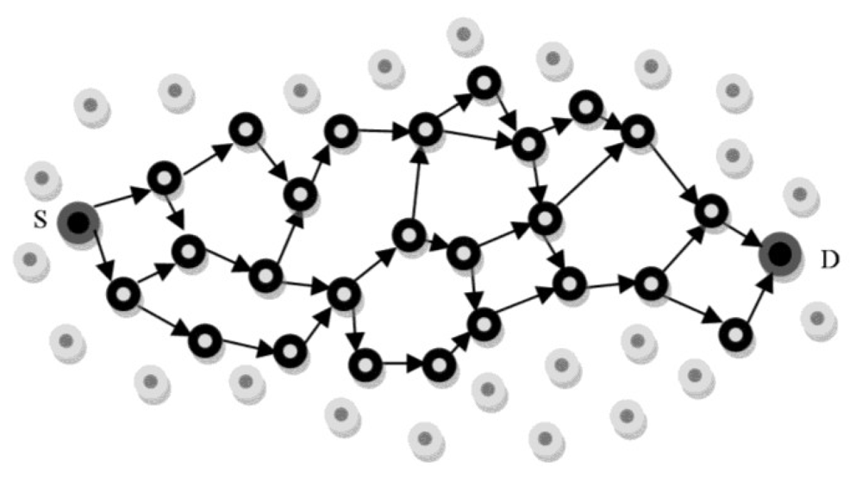

BLOCK DIAGRAM:
CASER
Deterministic routing
Random walk Routing
Use Shortest path
Use random selection path
Send data through head node
Send data through head node

SYSTEM SPECIFICATION
Hardware Requirements:

- System : Pentium IV 3.5 GHz.
- Hard Disk : 40 GB.
- Monitor : 14’ Colour Monitor.
- Mouse : Optical Mouse.
- Ram : 1 GB.
Software Requirements:

- Operating system : Windows XP or Windows 7, Windows 8.
- Coding Language : Java – AWT,Swings,Networking
- Data Base : My Sql / MS Access.
- Documentation : MS Office
- IDE : Eclipse Galileo
- Development Kit : JDK 1.6

