iPath: Path Inference in Wireless Sensor Networks
ABSTRACT:
Recent wireless sensor networks (WSNs) are becoming increasingly complex with the growing network scale and the dynamic nature of wireless communications. Many measurement and diagnostic approaches depend on per-packet routing paths for accurate and fine-grained analysis of the complex network behaviors. In this paper, we propose iPath, a novel path inference approach to reconstructing the per-packet routing paths in dynamic and large-scale networks. The basic idea of iPath is to exploit high path similarity to iteratively infer long paths from short ones. iPath starts with an initial known set of paths and performs path inference iteratively. iPath includes a novel design of a lightweight hash function for verification of the inferred paths. In order to further improve the inference capability as well as the execution efficiency, iPath includes a fast bootstrapping algorithm to reconstruct the initial set of paths. We also implement iPath and evaluate its performance using traces from large-scale WSN deployments as well as extensive simulations. Results show that iPath achieves much higher reconstruction ratios under different network settings compared to other state-of-the-art approaches.
iPath: Path Inference in Wireless Sensor Networks
EXISTING SYSTEM:
- With the routing path of each packet, many measurement and diagnostic approaches are able to conduct effective management and protocol optimizations for deployed WSNs consisting of a large number of unattended sensor nodes. For example, PAD depends on the routing path information to build a Bayesian network for inferring the root causes of abnormal phenomena.
- Path information is also important for a network manager to effectively manage a sensor network. For example, given the per-packet path information, a network manager can easily find out the nodes with a lot of packets forwarded by them, i.e., network hop spots. Then, the manager can take actions to deal with that problem, such as deploying more nodes to that area and modifying the routing layer protocols.
- Furthermore, per-packet path information is essential to monitor the fine-grained per-link metrics. For example, most existing delay and loss measurement approaches assume that the routing topology is given as a priori.
- The time-varying routing topology can be effectively obtained by per-packet routing path, significantly improving the values of existing WSN delay and loss tomography approaches.
DISADVANTAGES OF EXISTING SYSTEM:
- The growing network scale and the dynamic nature of wireless channel make WSNs become increasingly complex and hard to manage.
- The problem of existing approach is that its message overhead can be large for packets with long routing paths.
- Considering the limited communication resources of WSNs, this approach is usually not desirable in practice.
PROPOSED SYSTEM:
- In this paper, we propose iPath, a novel path inference approach to reconstruct routing paths at the sink side. Based on a real-world complex urban sensing network with all node generating local packets, we find a key observation: It is highly probable that a packet from node and one of the packets from ‘s parent will follow the same path starting from ‘s parent toward the sink. We refer to this observation as high path similarity.
- The basic idea of iPath is to exploit high path similarity to iteratively infer long paths from short ones. iPath starts with a known set of paths (e.g., the one-hop paths are already known) and performs path inference iteratively. During each iteration, it tries to infer paths one hop longer until no paths can be inferred.
- In order to ensure correct inference, iPath needs to verify whether a short path can be used for inferring a long path. For this purpose, iPath includes a novel design of a lightweight hash function. Each data packet attaches a hash value that is updated hop by hop. This recorded hash value is compared against the calculated hash value of an inferred path. If these two values match, the path is correctly inferred with a very high probability.
- In order to further improve the inference capability as well as its execution efficiency, iPath includes a fast bootstrapping algorithm to reconstruct a known set of paths.
ADVANTAGES OF PROPOSED SYSTEM:
- We observe high path similarity in a real-world sensor network.
- It’s an iterative boosting algorithm for efficient path inference.
- It’s a lightweight hash function for efficient verification within iPath.
- The proposed system further propose a fast bootstrapping algorithm to improve the inference capability as well as its execution efficiency.
- iPath achieves higher reconstruction ratio under different network settings compared to states of the art.
SYSTEM ARCHITECTURE:
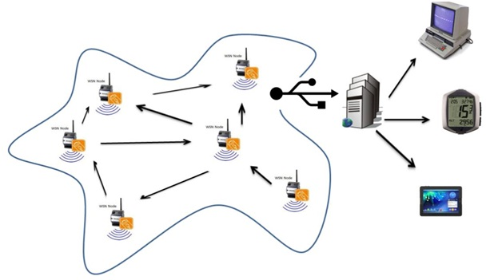

SYSTEM REQUIREMENTS
HARDWARE REQUIREMENTS:

- System : Pentium Dual Core.
- Hard Disk : 120 GB.
- Monitor : 15’’ LED
- Input Devices : Keyboard, Mouse
- Ram :
SOFTWARE REQUIREMENTS:

- Operating system : Windows 7.
- Coding Language : JAVA/J2EE
- Tool : Netbeans 7.2.1
- Database : MYSQL
REFERENCE:
Yi Gao, Student Member, IEEE, Wei Dong, Member, IEEE, Chun Chen, Member, IEEE, Jiajun Bu, Member, IEEE, ACM, Wenbin Wu, and Xue Liu, Member, IEEE, “iPath: Path Inference in Wireless Sensor Networks”, IEEE/ACM TRANSACTIONS ON NETWORKING, VOL. 24, NO. 1, FEBRUARY 2016.

