Contributory Broadcast Encryption with Efficient Encryption and Short Ciphertexts
ABSTRACT:
Traditional broadcast encryption (BE) schemes allow a sender to securely broadcast to any subset of members but require a trusted party to distribute decryption keys. Group key agreement (GKA) protocols enable a group of members to negotiate a common encryption key via open networks so that only the group members can decrypt the ciphertexts encrypted under the shared encryption key, but a sender cannot exclude any particular member from decrypting the ciphertexts. In this paper, we bridge these two notions with a hybrid primitive referred to as contributory broadcast encryption (ConBE). In this new primitive, a group of members negotiate a common public encryption key while each member holds a decryption key. A sender seeing the public group encryption key can limit the decryption to a subset of members of his choice. Following this model, we propose a ConBE scheme with short ciphertexts. The scheme is proven to be fully collusion-resistant under the decision n-Bilinear Diffie-Hellman Exponentiation (BDHE) assumption in the standard model. Of independent interest, we present a new BE scheme that is aggregatable. The aggregatability property is shown to be useful to construct advanced protocols.

EXISTING SYSTEM:
- Group key agreement (GKA) is another well-understood cryptographic primitive to secure group-oriented communications. A conventional GKA allows a group of members to establish a common secret key via open networks. However, whenever a sender wants to send a message to a group, he must first join the group and run a GKA protocol to share a secret key with the intended members.
- More recently, and to overcome this limitation, Wu et al. introduced asymmetric GKA, in which only a common group public key is negotiated and each group member holds a different decryption key.
- However, neither conventional symmetric GKA nor the newly introduced asymmetric GKA allow the sender to unilaterally exclude any particular member from reading the plaintext. Hence, it is essential to find more flexible cryptographic primitives allowing dynamic broadcasts without a fully trusted dealer.
DISADVANTAGES OF EXISTING SYSTEM:
- Need a fully trusted third party to set up the system.
- Existing GKA protocols cannot handle sender/member changes efficiently.
PROPOSED SYSTEM:
- We present the Contributory Broadcast Encryption (ConBE) primitive, which is a hybrid of GKA and BE.
- This full paper provides complete security proofs, illustrates the necessity of the aggregatability of the underlying BE building block and shows the practicality of our ConBE scheme with experiments.
- First, we model the ConBE primitive and formalize its security definitions. ConBE incorporates the underlying ideas of GKA and BE. A group of members interact via open networks to negotiate a public encryption key while each member holds a different secret decryption key. Using the public encryption key, anyone can encrypt any message to any subset of the group members and only the intended receivers can decrypt.
- We formalize collusion resistance by defining an attacker who can fully control all the members outside the intended receivers but cannot extract useful information from the ciphertext.
- Second, we present the notion of aggregatable broadcast encryption (AggBE). Coarsely speaking, a BE scheme is aggregatable if its secure instances can be aggregated into a new secure instance of the BE scheme. Specifically, only the aggregated decryption keys of the same user are valid decryption keys corresponding to the aggregated public keys of the underlying BE instances.
- Finally, we construct an efficient ConBE scheme with our AggBE scheme as a building block. The ConBE construction is proven to be semi-adaptively secure under the decision BDHE assumption in the standard model.
ADVANTAGES OF PROPOSED SYSTEM:
- We construct a concrete AggBE scheme tightly proven to be fully collusion-resistant under the decision BDHE assumption.
- The proposed AggBE scheme offers efficient encryption/decryption and short ciphertexts.
- Only one round is required to establish the public group encryption key and set up the ConBE system.

SYSTEM ARCHITECTURE:
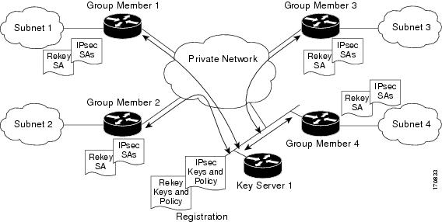
SYSTEM REQUIREMENTS:
HARDWARE REQUIREMENTS:

- System : Pentium IV 2.4 GHz.
- Hard Disk : 40 GB.
- Floppy Drive : 1.44 Mb.
- Monitor : 15 VGA Colour.
- Mouse : Logitech.
- Ram : 512 Mb.

SOFTWARE REQUIREMENTS:

- Operating system : Windows XP/7.
- Coding Language : JAVA
- IDE : Netbeans 7.4
- Database : MYSQL
REFERENCE:
Qianhong Wu, Member, IEEE, Bo Qin, Lei Zhang, Member, IEEE, Josep Domingo-Ferrer, Fellow, IEEE Oriol Farr`as, and Jes´us A. Manj´on, “Contributory Broadcast Encryption with Efficient Encryption and Short Ciphertexts”, IEEE TRANSACTIONS ON COMPUTERS 2015.

