Detecting Node Failures in Mobile Wireless Networks: A Probabilistic Approach
ABSTRACT:
Detecting node failures in mobile wireless networks is very challenging because the network topology can be highly dynamic, the network may not be always connected, and the resources are limited. In this paper, we take a probabilistic approach and propose two node failure detection schemes that systematically combine localized monitoring, location estimation and node collaboration. Extensive simulation results in both connected and disconnected networks demonstrate that our schemes achieve high failure detection rates (close to an upper bound) and low false positive rates, and incur low communication overhead. Compared to approaches that use centralized monitoring, our approach has up to 80% lower communication overhead, and only slightly lower detection rates and slightly higher false positive rates. In addition, our approach has the advantage that it is applicable to both connected and disconnected networks while centralized monitoring is only applicable to connected networks. Compared to other approaches that use localized monitoring, our approach has similar failure detection rates, up to 57% lower communication overhead and much lower false positive rates (e.g., 0.01 versus 0.27 in some settings).
EXISTING SYSTEM:
- One approach adopted by many existing studies is based on centralized monitoring. It requires that each node send periodic “heartbeat” messages to a central monitor, which uses the lack of heartbeat messages from a node (after a certain timeout) as an indicator of node failure.
- This approach assumes that there always exists a path from a node to the central monitor, and hence is only applicable to networks with persistent connectivity.
- Another approach is based on localized monitoring, where nodes broadcast heartbeat messages to their one-hop neighbors and nodes in a neighborhood monitor each other through heartbeat messages. Localized monitoring only generates localized traffic and has been used successfully for node failure detection in static networks
DISADVANTAGES OF EXISTING SYSTEM:
- The existing approach can lead to a large amount of network-wide traffic, in conflict with the constrained resources in mobile wireless networks.
- When being applied to mobile networks, the existing approach suffers from inherent ambiguities—when a node A stops hearing heartbeat messages from another node B, A cannot conclude that B has failed because the lack of heartbeat messages might be caused by node B having moved out of range instead of node failure.
- A common drawback of probe-and-ACK, heartbeat and gossip based techniques is that they are only applicable to networks that are connected. In addition, they lead to a large amount of network-wide monitoring traffic.
PROPOSED SYSTEM:
- In this paper, we propose a novel probabilistic approach that judiciously combines localized monitoring, location estimation and node collaboration to detect node failures in mobile wireless networks. Specifically, we propose two schemes.
- In the first scheme, when a node A cannot hear from a neighboring node B, it uses its own information about B and binary feedback from its neighbors to decide whether B has failed or not.
- In the second scheme, A gathers information from its neighbors, and uses the information jointly to make the decision. The first scheme incurs lower communication overhead than the second scheme. On the other hand, the second scheme fully utilizes information from the neighbors and can achieve better performance in failure detection and false positive rates.
ADVANTAGES OF PROPOSED SYSTEM:
- Simulation results demonstrate that both schemes achieve high failure detection rates, low false positive rates, and incur low communication overhead.
- Our approach has the advantage that it is applicable to both connected and disconnected networks.
- Compared to other approaches that use localized monitoring, our approach has similar failure detection rates, lower communication overhead and much lower false positive rate.
- Our approach only generates localized monitoring traffic and is applicable to both connected and disconnected networks.
SYSTEM ARCHITECTURE:
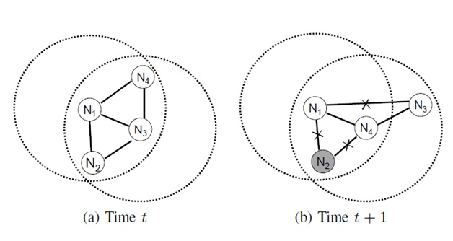
SYSTEM CONFIGURATION

Hardware Configuration

Processor - Pentium –IV(Min)
- Speed - 3.5 Ghz
- RAM - 1 GB(min)
- Hard Disk - 20 GB
- Key Board - Standard Windows Keyboard
- Mouse - Two or Three Button Mouse

Software Configuration
- Operating System : Windows XP
- Programming Language : JAVA(AWT,Swings,Networkin)
- Back End : MS Access/MY Sql
- Documentation : MS Office
- IDE : Eclipse -- Galileo

