Secure Spatial Top-k Query Processing via Untrusted Location-Based Service Providers
ABSTRACT:
This paper considers a novel distributed system for collaborative location-based information generation and sharing which become increasingly popular due to the explosive growth of Internet-capable and location-aware mobile devices. The system consists of a data collector, data contributors, location-based service providers (LBSPs), and system users. The data collector gathers reviews about points-of-interest (POIs) from data contributors, while LBSPs purchase POI data sets from the data collector and allow users to perform spatial top-k queries which ask for the POIs in a certain region and with the highest k ratings for an interested POI attribute. In practice, LBSPs are untrusted and may return fake query results for various bad motives, e.g., in favor of POIs willing to pay. This paper presents three novel schemes for users to detect fake spatial snapshot and moving top-k query results as an effort to foster the practical deployment and use of the proposed system. The efficacy and efficiency of our schemes are thoroughly analyzed and evaluated.
EXISTING SYSTEM:
- Our work is most related to data outsourcing, for which we can only review representative schemes due to space constraints. The framework of data outsourcing was first introduced, in which a data owner outsources its data to a third-party service provider who is responsible for answering the data queries from either the data owner or other users. In general, there are two security concerns in data outsourcing: data privacy and query integrity.
- A bucketization approach was proposed, to enable efficient range queries over encrypted data, which was recently improved.
- Shi et al. presented novel methods for multi-dimensional range queries over encrypted data.
- Some most recent proposals aim at secure ranked keyword search or fine-grained access control over encrypted data.

DISADVANTAGES OF EXISTING SYSTEM:
- We observe two essential drawbacks with current top-k query services.
- First, individual LBSPs often have very small data sets comprising POI reviews. This would largely affect the usefulness and eventually hinder the more prevalent use of spatial top-k query services. Continue with the restaurant example. The data sets at individual LBSPs may not cover all the Italian restaurants within a search radius. Additionally, the same restaurant may receive diverse ratings at different LBSPs, so users may get confused by very different query results from different LBSPs for the same query. A leading reason for limited data sets at individual LBSPs is that people tend to leave reviews for the same POI at one or at most only a few LBSPs’s websites which they often visit.
- Second, LBSPs may modify their data sets by deleting some reviews or adding fake reviews and return tailored query results in favor of the restaurants that are willing to pay or against those that refuse to pay.2 Even if LBSPs are not malicious, they may return unfaithful query results under the influence of various attacks such as the Sybil attack whereby the same attacker can submit many fake reviews for the same POI.
PROPOSED SYSTEM:
- In this paper, we propose three novel schemes to tackle the above challenge for fostering the practical deployment and wide use of the envisioned system. The key idea of our schemes is that the data collector pre-computes and authenticates some auxiliary information (called authenticated hints) about its data set, which will be sold along with its data set to LBSPs.
- To faithfully answer a top-k query, a LBSP need return the correct top-k POI data records as well as proper authenticity and correctness proofs constructed from authenticated hints. The authenticity proof allows the query user to confirm that the query result only consists of authentic data records from the trusted data collector’s data set, and the correctness proof enables the user to verify that the returned top-k POIs are the true ones satisfying the query.
- The first two schemes both target snapshot top-k queries but differ in how authenticated hints are pre-computed and how authenticity and correctness proofs are constructed and verified as well as the related communication and computation overhead.
- The third scheme, built upon the first scheme, realizes efficient and verifiable moving top-k queries. The efficacy and efficiency of our schemes are thoroughly analyzed and evaluated.
ADVANTAGES OF PROPOSED SYSTEM:
- Our schemes support both snapshot and moving top-k queries, which enable users to verify the authenticity and correctness of any top-k query result.
- The efficacy and efficiency of our schemes are thoroughly analyzed and evaluated through detailed simulation studies.
SYSTEM ARCHITECTURE:
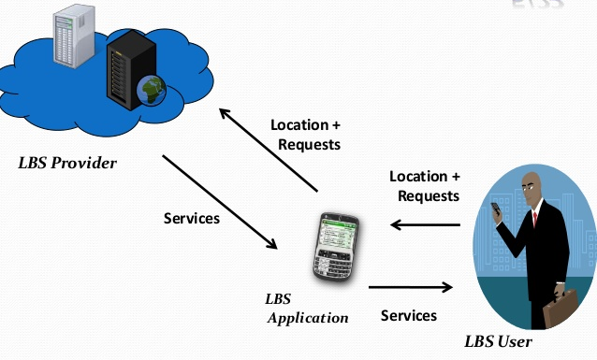
MODULES:

- System Model
- Location Based Service Provider
- Query Processing
- Query-Result Verification

MODULES DESCRIPTION:

System Model
- In the first module we develop the System model module. In this module we develop first the data collector module. The data collector module provides you the functionality of accessing the ratings provided by the user when the search is accompanied with respect to the specific location. This will also comes with the particulars of users who are registered with the system.
- Next we develop the User Module. The User has to register initially and get the login credentials from the system. This provides the user to login to the system and search for a place. The search will provide you the result based on the interests provided by the user at the time of registration. This will show you the exact location in the google-map and the Landmark associated with the searching text.

Location Based Service Provider

- In this module, we develop the Location Based Services Provide Modules. Location-based services Provider (LBSP) are a general class of computer program-level services that use location data to control features. As such LBSP is an information service which uses information on the geographical position of the mobile device.
- LBSP are used in a variety of contexts, such as health, indoor object search, entertainment, work, personal life, etc. LBSP include services to identify a location of a person or object, such as discovering the nearest Shopping mall or the where about of a location. Adding location information is carried out under the LBSP using the Google-Map Latitude and Longitude. The locations will be added based on the latitude and longitude of the exact location in Google-API.

Query Processing
- The LBSP purchases the data sets of interested POI categories from the data collector. For every POI category selected by the LBSP, the data collector returns the original data set D, the signatures on Merkle root hashes, and all the intermediate results for constructing the Merkle hash tree.
- Alternatively, the data collector can just return the first two pieces of information and let the LBSP itself perform a onetime process to derive the third piece in the same way as the date collector.

Query-Result Verification
- Now we discuss how the user verifies the authenticity and correctness of the query result, which can be done via a small plug-in developed by the data collector and installed on his web browser.
- For authenticity verification, the user checks if every piece of information in the query result can lead to the same Merkle root hash matching the data collector’s signature. Specifically, the user first determines which of the above five cases belongs to based on its message format. He then derives the indexes for all related POIs.
- To perform correctness verification, the user first checks if zones I encloses the query region R. If so, he proceeds with the following verifications in accordance with the aforementioned correctness condition used in query processing

SYSTEM REQUIREMENTS:
HARDWARE REQUIREMENTS:

- System : Pentium IV 2.4 GHz.
- Hard Disk : 40 GB.
- Floppy Drive : 1.44 Mb.
- Monitor : 15 VGA Colour.
- Mouse : Logitech.
- Ram : 512 Mb.
SOFTWARE REQUIREMENTS:

- Operating system : Windows XP/7.
- Coding Language : JAVA/J2EE
- IDE : Netbeans 7.4
- Database : MYSQL
REFERENCE:
Rui Zhang, Member, IEEE, Jingchao Sun, Student Member, IEEE, Yanchao Zhang, Senior Member, IEEE, and Chi Zhang, Member, IEEE, “Secure Spatial Top-k Query Processing via Untrusted Location-Based Service Providers”, IEEE TRANSACTIONS ON DEPENDABLE AND SECURE COMPUTING, VOL. 12, NO. 1, JANUARY/FEBRUARY 2015.

