The Server Provisioning Problem for Continuous Distributed Interactive Applications
ABSTRACT:
In this paper, we study the server provisioning problem for continuous Distributed Interactive Applications (DIAs) whose application states not only change because of the operations performed by participants, but also evolve along with the passing of time. We focus on finding the locations of servers for hosting continuous DIAs, with the goals of optimizing the interactivity performance while fulfilling the consistency and fairness requirements. We show that the server provisioning problem is challenging by presenting its NP-hardness and non-approximability results under several conditions. We propose two efficient server placement algorithms and analyze their approximation ratios. The approximation ratio of the proposed M-BETTER algorithm is quite close to a lower bound for any polynomial-time algorithm. We also conduct experimental evaluations to compare the proposed algorithms with several baseline server placements.
EXISTING SYSTEM:
- Zhang and Tang have proved that the minimum achievable interaction time between clients for fulfilling the consistency and fairness requirements is given by the length of the longest interaction path among all clients.
- The classical k-center and k-median problems have been strongly advocated for server placement in the Internet. These two problems aim to place k servers in the network to minimize the maximum network latency and the total network latency from the clients to their nearest servers respectively. They well suit the need of web content delivery whose performance is primarily determined by how fast the contents stored on the servers are delivered to the clients.
- Zhang and Tang studied how to optimize the assignment of clients to servers for DIAs given a set of servers placed.
DISADVANTAGES OF EXISTING SYSTEM:
- A major barrier to the quality of experience in DIAs is the communication latency across the network.
- Even with distributed server infrastructures, the network latency cannot be completely eliminated from the interactions between clients in DIAs. The network latency involved in client interactions is directly affected by the locations where servers are placed. Thus, server placement is of crucial importance to the interactivity performance of DIAs.
- The network latencies do not satisfy the triangle inequality.
- The locations where servers can be placed are restricted
- The number of server locations to select is limited
PROPOSED SYSTEM:
- This paper explores server provisioning for continuous DIAs with consideration of synchronization delays, which lead to a different optimization objective from that for discrete DIAs.
- In this paper, we formally define the problem of finding the locations of servers for hosting continuous DIAs, with the goal of optimizing the interactivity performance while maintaining the consistency and fairness of DIAs.
- We further prove that the server provisioning problem cannot be approximated within any bounded factor under condition (i), within a factor of 3=2 under condition (ii), and within a factor of 4=3 under condition (iii). We propose two efficient server placement algorithms and show that they significantly outperform the baseline server placements by means of both theoretical analysis and experimental evaluation. In particular, the proposed M-BETTER algorithm has an approximation ratio quite close to the lower bound of 3=2.
ADVANTAGES OF PROPOSED SYSTEM:
- From the computability perspective, the difference in the optimization objective gives rise to a much richer set of non-approximability results in this paper than the existing one.
- We have shown that this is a challenging problem by analyzing its hardness under various conditions.
- We have proved that the problem cannot be approximated within any constant factor for networks without the triangle inequality; within a factor of 3=2 if the choices of server locations are restricted; and within a factor of 4=3 if there is a limit on the number of server locations to select. We have proposed two server placement algorithms M-GREEDY and M-BETTER with approximation ratios of 2 and 5/3 respectively.

SYSTEM ARCHITECTURE:
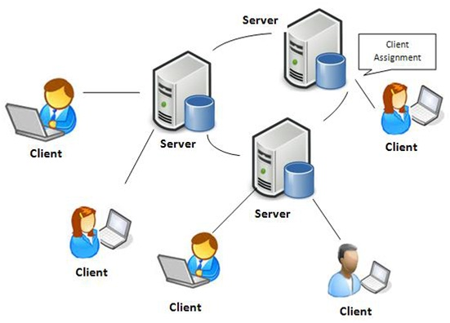
SYSTEM REQUIREMENTS:
HARDWARE REQUIREMENTS:
- System : Pentium Dual Core.
- Hard Disk : 120 GB.
- Monitor : 15’’ LED
- Input Devices : Keyboard, Mouse
- Ram : 1 GB
SOFTWARE REQUIREMENTS:
- Operating system : Windows 7.
- Coding Language : JAVA/J2EE
- Tool : Netbeans 7.2.1
- Database : MYSQL
REFERENCE:
Hanying Zheng and Xueyan Tang, Senior Member, IEEE, “The Server Provisioning Problem for Continuous Distributed Interactive Applications”, IEEE TRANSACTIONS ON PARALLEL AND DISTRIBUTED SYSTEMS, VOL. 27, NO. 1, JANUARY 2016.

