Enabling Cloud Storage Auditing With Verifiable Outsourcing of Key Updates

ABSTRACT
Key-exposure resistance has always been an important issue for in-depth cyber defence in many security applications. Recently, how to deal with the key exposure problem in the settings of cloud storage auditing has been proposed and studied. To address the challenge, existing solutions all require the client to update his secret keys in every time period, which may inevitably bring in new local, burdens to the client, especially those with limited computation resources, such as mobile phones. In this paper, we focus on how to make the key updates as transparent as possible for the client and propose a new paradigm called cloud storage auditing with verifiable outsourcing of key updates. In this paradigm, key updates can be safely outsourced to some authorized party, and thus the key-update burden on the client will be kept minimal. In particular, we leverage the third party auditor (TPA) in many existing public auditing designs, let it play the role of authorized party in our case, and make it in charge of both the storage auditing and the secure key updates for key-exposure resistance. In our design, TPA only needs to hold an encrypted version of the client’s secret key while doing all these burdensome tasks on behalf of the client. The client only needs to download the encrypted secret key from the TPA when uploading new files to cloud. Besides, our design also equips the client with capability to further verify the validity of the encrypted secret keys provided by the TPA. All these salient features are carefully designed to make the whole auditing procedure with key exposure resistance as transparent as possible for the client. We formalize the definition and the security model of this paradigm. The security proof and the performance simulation show that our detailed design instantiations are secure and efficient.

EXISTING SYSTEM
Cloud storage is universally viewed as one of the most important services of cloud computing. Although cloud storage provides great benefit to users, it brings new security
challenging problems. One important security problem is how to efficiently check the integrity of the data stored in cloud. In recent years, many auditing protocols for cloud storage have been proposed to deal with this problem. The key exposure problem is another important problem in cloud storage auditing.
Disadvantages of Existing System:
- Checking the integrity of the data inefficient
- Once the client’s secret key for storage auditing is exposed to cloud, the cloud is able to easily hide the data loss incidents for maintaining its reputation, even discard the client’s data rarely accessed for saving the storage space.
PROPOSED SYSTEM
We propose a new paradigm called cloud storage auditing with verifiable outsourcing of key updates. In this new paradigm, key-update operations are not performed by the client, but by an authorized party. The authorized party holds an encrypted secret key of the client for cloud storage auditing and updates it under the encrypted state in each time period. The client downloads the encrypted secret key from the authorized party and decrypts it only when he would like to upload new files to cloud. In addition, the client can verify the validity of the encrypted secret key. We design the first cloud storage auditing protocol with verifiable outsourcing of key updates. In our design, the third party auditor (TPA) plays the role of the authorized party who is in charge of key updates. In addition, similar to traditional public auditing protocols, another important task of the TPA is to check the integrity of the client’s files stored in cloud. The TPA does not know the real secret key of the client for cloud storage auditing, but only holds an encrypted version. In the detailed protocol, we use the blinding technique with homomorphic property to form the encryption algorithm to encrypt the secret keys held by the TPA. It makes our protocol secure and the decryption operation efficient. Meanwhile, the TPA can complete key updates under the encrypted state. The client can verify the validity of the encrypted secret key when he retrieves it from the TPA.

Advantages of Proposed System:
- In this protocol, key updates are outsourced to the TPA and are transparent for the client
- The TPA only sees the encrypted version of the client’s secret key, while the client can further verify the validity of the encrypted secret keys when downloading them from the TPA
SYSTEM ARCHITECTURE
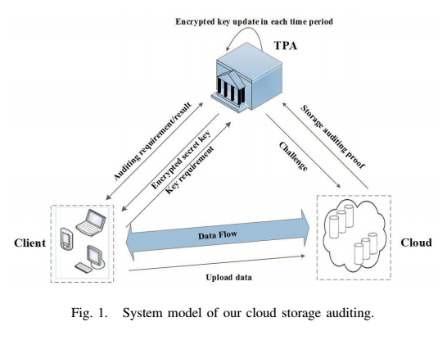

MODULES
We have 3 main modules in this project;
- Client Module
- Cloud Module
- Third Party Auditor (TPA)
Client:
The client is the owner of the files that are uploaded to cloud. The total size of these files is not fixed, that is, the client can upload the growing files to cloud in different time points.
Cloud:
The cloud stores the client’s files and provides download service for the client.
TPA:
The TPA plays two important roles: the first is to audit the data files stored in cloud for the client; the second is to update the encrypted secret keys of the client in each time period.
SYSTEM CONFIGURATION

Hardware Configuration

Processor - Pentium –IV
- Speed - 1.1 Ghz
- RAM - 256 MB(min)
- Hard Disk - 20 GB

Software Configuration
- Operating System : Windows XP
- Programming Language : JAVA

